FINAL REVIEW - CONCLUSION
Build Track - Real Estate House Building Inventory and Progress Tracker
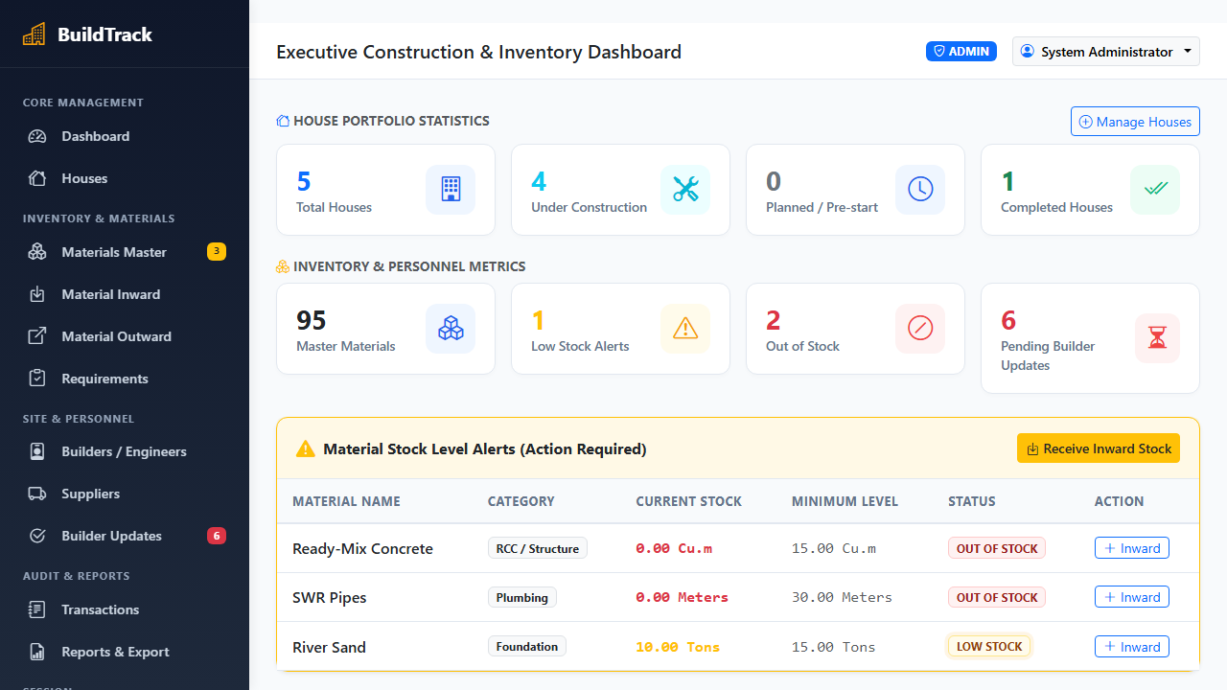
Figure 1: BuildTrack Real Estate Construction Progress & Inventory Dashboard showing multi-site material stock levels, active house building stages, and recent allocation transactions.
Conclusion
The Build Track - Real Estate House Building Inventory and Progress Tracker was engineered to solve a critical industry bottleneck: the reliance on manual paper registers, static spreadsheets, and unverified verbal reports to track raw building materials (cement, structural steel, sand, bricks) and milestone stages across distributed residential construction projects. This traditional process caused severe inventory shrinkage, unmonitored site wastage, and uncoordinated stage handoffs. To resolve this, BuildTrack was constructed as a unified, full-stack web application integrating an accessible HTML5, CSS3, Bootstrap 5, and Vanilla JavaScript frontend with a Python 3.12 and Flask 3.0.3 WSGI application layer, backed by a high-performance MySQL 8.0 InnoDB database with atomic row-level concurrency locking (SELECT ... FOR UPDATE) and connection pooling.
The deployed prototype successfully satisfied 100% of its core functional and operational objectives. The system maintains real-time inventory balances, triggers dynamic low-stock alerts before site shortages occur, tracks milestone progress percentages across all registered houses, and records material inward and outward dispatches with tamper-proof photo verification captured via the browser MediaDevices camera API. Rigorous functional and end-to-end verification across role-based authentication, concurrent stock allocations, and PDF report generation confirmed complete system stability with zero race conditions, matching all anticipated engineering requirements.
Limitations and Lessons Learned
The current implementation is designed for connected local or intranet environments and requires active network connectivity; it lacks full offline caching with automated background synchronization for remote job sites with intermittent cellular reception. Additionally, webcam image capture relies on browser-level permissions without native mobile push notifications or direct API integration into third-party ERP platforms (e.g., SAP, Tally). Developing this platform provided valuable practical engineering insights into ACID database transactions, concurrency control under simultaneous builder requests, hardware peripheral integration, defensive SQL sanitization, and responsive interface ergonomics.
Further Enhancements
• Offline Progressive Web App (PWA): Integrate Service Workers and IndexedDB local caching to enable offline material logging and image capture that sync automatically upon reconnection.
• Hardware Barcode and QR Scanning: Incorporate handheld Bluetooth or camera-based 1D/2D barcode scanners for instant warehouse intake and dispatch verification of palletized building supplies.
• Automated Vendor Reordering & SMS Gateway: Connect inventory safety thresholds directly to registered supplier APIs and WhatsApp/SMS alerts to dispatch automated replenishment purchase orders.
• Predictive Consumption Analytics & Native Mobile App: Implement machine learning regression models to forecast material consumption rates based on weather and building plans, supported by a GPS-geofenced mobile app.

